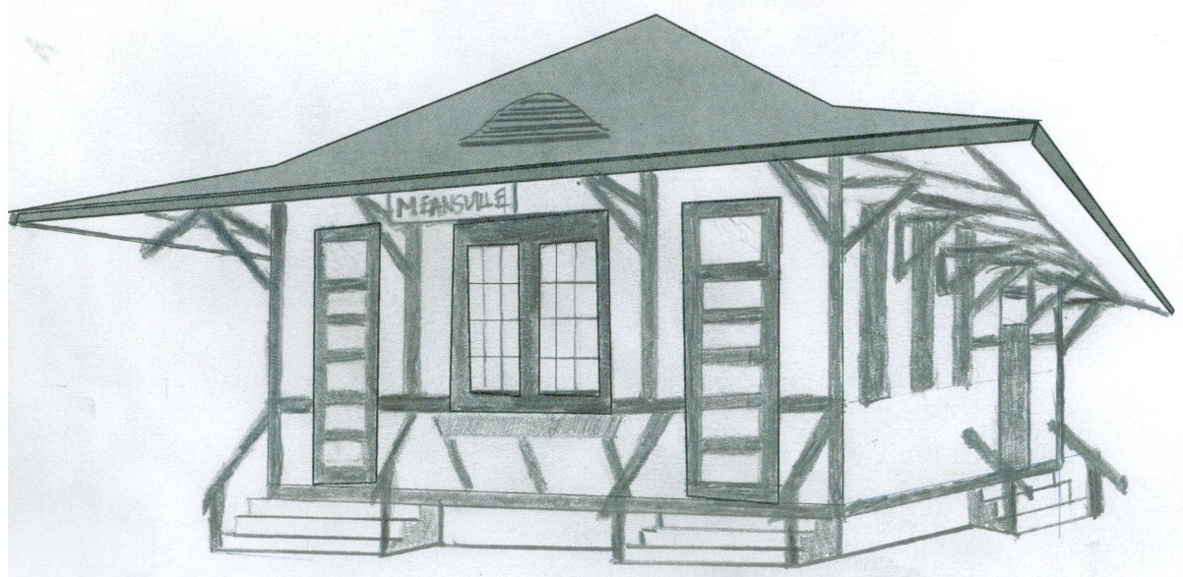

Meansville Old Train Depot/City Hall
T-shirt Design
Meansville
5K/10K Fun Run/Walk
Saturday, 19 June 2021

Event Location: Meansville Fire Station, 40 Means St, Meansville, GA 30295.
R/W start window: 7:30 - 10:00 a.m.
Course Description: GA Hwy 109 will be closed to trucker traffic due to Gola Bridge replacement. 5K is generally flat with paved and dirt roads. 10K route has paved and dirt roads, and has hills.
Souvenir: Every registered participant gets a T-shirt that will reflect the Old Meansville Railroad Depot/City Hall.
Proceeds: Benefits community and Veteran programs which include assisting and honoring Veterans and their families, and community patriotic programs.
Entry Cost Information: Registration is $25 with T-shirt. Registration prior to 11 June will get T-shirt at the event. Late and day of registration, T-shirt will be delivered at a later date. Those who registered, but can not attend, T-shirt will be delivered. Extra T-shirt: $10. Refreshments will be provided at rest areas and start/finish area.
Honor a deceased Veteran with his/her name on back of T-shirt with donation of $50.
Make checks payable to: Pike County American Legion Post 197 and mail with below Registration Form to: Event Director, ATTN: Bryan Richardson, P.O. Box 781, Zebulon, GA 30295.
Questions: Contact Event Director at email: rich5060@bellsouth.net / Cell #: 678-764-2611
No refunds will be issued for any reason

-----------------------detach here -----------------------

5K/10K Fun Run/Walk REGISTRATION FORM 19 June 2021
PLEASE PRINT LEGIBLY

Name:_______________________________________________________________
Address:_____________________________________________________________
City, State, Zipcode ____________________________________________________
Phone:_____________________________E-mail:____________________________
SHIRT SIZES (circle): Y-Size____ S M L XL XXL XXXL XXXXL
Deceased Veteran’s name to be honored:___________________________________

Waiver (MUST BE SIGNED)
In consideration of your accepting this entry, I, the below signed, intending to be legally bound, for myself, my heirs, my executors and administrators, waive and release and any all rights and claims for damages I may have against the race, and sponsors and their representatives, successors and assigns for any and all injuries suffered by me in said event. I attest that I will participate in this event as a fitness event, that I am physically fit and sufficiently trained for the distance of this event. Furthermore, I hereby grant full permission to use my name and likeliness, as well as any photographs and any record of this event in which I may appear for any legitimate purpose, including advertising and promotion.
Signature_________________________________________Date______________
Parent or Guardian if under 18__________________________________________

